**Assignment 1**

A folder hierarchy is given in the attached image. You have to create that folder structure using commands in the terminal. Take screenshots of the commands, attach them in a pdf and submit it in the classroom portal before deadline.

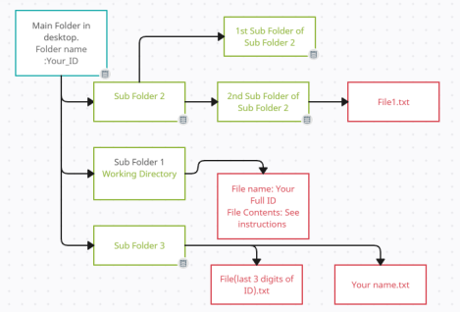1. You should create a folder on the desktop using the terminal. Folder Name should be your full ID. This folder will have 3 sub folders.

2. Sub Folder 1 should be named as WorkingDirectory. After creating this folder, you should open this folder using terminal (cd folder) and work from there. This folder will contain a text file named your full id.txt . Write the following line in this text file “Assignment 1 commands: ” while creating it.

3. Sub Folder 2 (named “Task1”) contains 2 folders. The empty folder should be named “empty” and the other one should be named “Numbers”. The Numbers folder will have a file “File1.txt” and this file should contain 15 random numbers (A single number in each line).

4. Sub Folder 3 (named “Introduction”) should have 2 files. The file names are given in the diagram. First file should contain your full ID and the 2nd file should contain your full name.

5. Now you should copy the “Numbers” folder to Sub Folder 3 and you should rename the file inside this folder as “Numbers.txt”. Show from (Last 3 digits of Your ID%10) no. line

to 10th line in terminal using file read commands. Now delete both empty and numbers folder of Task 1. Now change directory to Sub Folder 3 (“Introduction”). 6. Change permission of “Numbers.txt” according to the following table.

| **Owner** | | | **Owners’ Group Others** | |
| --- | --- | --- | --- | --- |
| **_** | **w** | **-** | **- - x r w** | **-** |

7. Finally, open “Your full ID.txt” file inside the WorkingDirectory folder and append all the commands for the assignment.

**N.B: All files/folder should be created from the terminal. All files/folders should be written/edited, moved, copied, deleted using commands from the terminal. You should write as few lines of commands as possible.**